Abstract Expressionism in the Philippines
Abstract Expressionism in the Philippines was one of many post-WWII movements that grew out of a desire to remain current with international artistic trends. Increased access to Western state grants and educational opportunities in the Philippines’ former colonising power, the United States, helped to deliver many of the country’s most esteemed artists a formal education. For instance, Jose Joya (1931- 1995) and Lee Aguinaldo (1933- 2007) studied at the Cranbrook Academy of Art in Michigan and the Culver Military Academy in Indiana respectively. The Filipino audience perceived abstraction as failed mimetic representation, and public reception of abstract art was characterized by indifference or outright antagonism, even during the 1970s as the Philippine art market began to open up to abstraction. However, while abstraction was regarded as purely decorative in some circles, it was seen as cerebral in others. In examining intersections between modern-contemporary expression and pre-colonial visual languages, some critics have argued that abstraction demonstrates affinities with forms present in textile and mat weaving from both Northern and Southern upland and riverine ethnolinguistic communities, as well as in the architecture, dress patterns, metal work and woodcraft of Muslim and Lumad communities in Mindanao.
Jose Joya was an important figure in the development of Abstract Expressionism in the Philippines. Joya had significant influence over successive generations of abstract-expressionist painters through his dedication to teaching, especially at the University of the Philippines College of Fine Arts. His teaching post allowed him to expand his network outside Manila, specifically through the Visayas (via University of the Philippines Cebu College for instance). Other key artist-art-educators from the Philippines include Florencio Concepcion and Constancio Bernardo. Concepcion took his postgraduate studies at the Accademia di Belle Arte in Rome and served as Dean of the University of the East College of Fine Arts. Bernardo studied with Joseph Albers at Yale University and later taught art at University of the Philippines. Fernando Zobel was a much earlier artist-art educator who similarly brought the influence of western abstract expressionist art to the Philippines when he returned to the Philippines shortly after graduating from Harvard University in 1949. Zobel eventually settled in Spain where he established the Museum of Spanish Abstract Art in Cuenca. However, before migrating to Spain, Zobel bequeathed his seminal collection of early Philippine modernist art to the Ateneo Art Gallery and nurtured a progeny of modernist advocate-critics including Emmanuel Torres and Leonidas Benesa.
Filipino critics including Torres suggest Zobel’s Abstract Expressionist period occurred between 1954-1957 when he was thought to have taken a “musical approach to painting,” before shifting to a chromatically streamlined calligraphic phase. More evident traces of gestural North American Abstract Expressionism are found in the work of Joya and Bernardo, whose paintings often radiate from a compositional core. The inclination to build compositions around masses of texture and colour is also demonstrated in the works Aguinaldo produced during the early 1960s before he took to a more overtly geometric stream of abstraction from the late 1960s up until his death. A later generation of practitioners whose collective works demonstrate an unconscious shift across various streams of abstraction include artists such as J. Elizalde Navarro, Ray Albano, Charito Bitanga, Phyllis Zaballero, Edwin Wilwayco, Oscar Villamiel, Eghai Roxas, among many others.
One key point of divergence between Philippine Abstract Expressionism and its American counterpart is the former’s casual regard for gestural painting. Unlike much of the debate that surrounded the work of Northern American Abstract Expressionists, particularly Jackson Pollock who had been propped up as the epitome of creative spontaneity, very little critical attention was paid to how Philippine Abstract Expressionism seemed unburdened by the desire to draw from primal impulses, how in effect, the work was undertaken in a more calculated manner. Benesa, a key Filipino modernist critic describing Joya states: “A number of the drawings and sketches in the mid-sixties show that, however spontaneous and expressionistic the gestures of the artist may appear in the final work, in the tradition of action painting, they have been rehearsed beforehand through the various disciplines of linear melody and tonal rhythm.” Despite his inclination toward premeditation, Joya is still generally upheld as representative of his generation of Philippine abstractionists, as he eventually underwent a degree of stylistic liberation, which critics suggest is evidenced in the diminished “stiffness in his drawing hand” rendered salient in his technique following his departure from the Philippines to pursue further studies in Europe and the US. Benesa partly credits Joya’s studies overseas for his more visibly organic and charged approach to drawing. Joya’s shift toward using “rivulets of auto-creative line” is seen as part of his shift toward drawing from an inward impulse, and privileging an inner reality, as opposed to external or physical one.
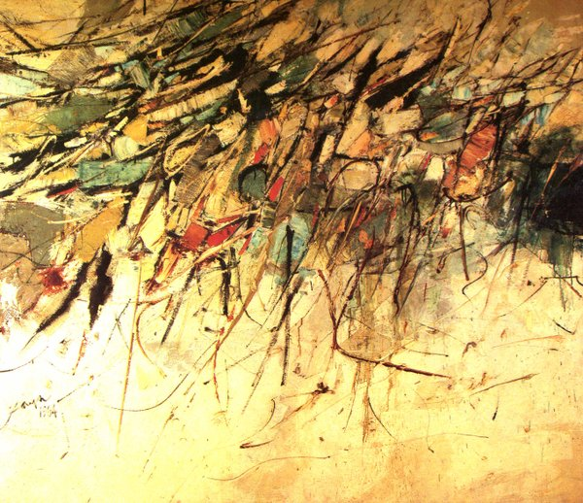
Jose Joya, Hills of Nikko, 1964, 172 x 198.8 cm, Collection of National Museum of the Philippines
Substantial anthropological and cultural scholarship has critically examined whether global pockets of Abstract Expressionism are merely derivative of American Abstract Expressionism. These critical accounts have pointed out that, while Abstract Expressionism has become enfolded into a canon of art history subjecting it to accounts of one-way transfer from the West to other parts of the world. However, prominent Western Abstract Expressionist artists have expressed a debt to Asian calligraphic scroll painting. It is this assertion, encumbered with the postcolonial thrust to establish national identity, which appears to have persuaded artists including Joya to modify his approach to abstraction, though arguably in a mitigated sense, to a referential phase. Joya, for instance, rendered overtly Filipino icons, like the Muslim Torogan (1985), using reductive line and colour. Current scholarship does seem to settle these art historical questions by arguing that a form of artistic poaching may have unconsciously influenced the way artists negotiated issues of origination. The logic proposed is that they were first given to a comparatively more geometric stream of abstraction and then eventually moved to a degree of symbology which the critic Alice Guillermo attributes to cabalistic and mandala motifs coming out of a growing interest in pre-colonial motifs which became more widely circulated post WWII onward.
References and further reading
___(1973) Joya Drawings, Manila: Vera Reyes, Inc. (With an extensive introduction by Leonidas Benesa.)
----(1996) Joya, Manila: D. Baldovino Enterprises. (This monograph on the National Artist most associated with Philippine Abstract Expressionism includes a foreword by National Artist for Literature Francisco Arcellana and color-plates of a range of the artist’s body of work. The publication is released through his brother-in-law’s office.)
Beltran, H. Jr. (Ed.) (2003) The National Artists of the Philippines 1999-2003 Volume 2, Manila: National Commission for Culture and the Arts. (This contains an essay on Jose Joya, “Epitome of Philippine Abstraction” by Dr. Alice Guillermo).
Gatbonton, J. (Ed) (1992) Art Philippines, Manila: The Crucible Workshop. (Traces the rise of Philippine abstraction more definitively to post-WWII and the emergence of Neo-Realism and consequent influx of information on international modernist tendencies. This case is made primarily by the essay on the 1950s written by the critic, Emmanuel Torres).
Herrera, M.V., Chikiamco, C. et al. (2011) The Life and Art of Lee Aguinaldo. Manila: Vibal Foundation. (A comprehensive monograph on one of the two major proponents of Philippine Abstract Expressionism.)
Ledesma, P. K. and Guerrero, A. (1974) The Struggle for Philippine Art, Manila: Purita Kalaw Ledesma. (An embedded account of the emergent years of Philippine modernism from the pioneering head of the Art Association of the Philippines).
Reyes, C. (1989) Conversations on Philippine Art, Manila: Cultural Center of the Philippines. (Substantial interviews on stylistic development with artists including Lee Aguinaldo and Jose Joya, covers an account of Joya’s formative years while on grants in Europe and America).
Torres, E. (1994) Philippine Abstract Painting, Manila: Cultural Centre of the Philippines. (Post-exhibit publication in line with the exhibition Fifty Years of Philippine Abstract Painting held at the CCP from October-December 1991).

